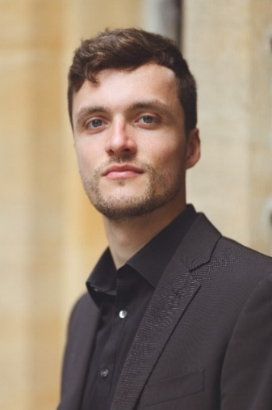**Vita**

Name: Steven van der Linden

Date of birth: 9th of February, 1998

Website: stevenvanderlinden.com

**Musical education**

2007-2013: Alto in the National Boys’ Choir, conducted by Suzanne Verburg and Wilma ten Wolde. In this choir we sang in all the big venues throughout the Netherlands and performed pieces like the *Matthäus Passion* and Mahler’s 8th with conductors like Mariss Jansons, Iván Fischer and Jaap van Zweden.

2013-2018: Tenor in the National Mixed Youth Choir, conducted by David Wilson-Johnson, Louis Buskens and Wilma ten Wolde. Multiple solo parts in for example Fauré’s *Requiem*. Concerts with Iván Fischer, Laszlo Nemes and Sigvards Klava.

2018-2020: Bachelor Voice at the Hochschule für Musik „Hanns Eisler” Berlin with Prof. Scot Weir. Part of Wolfram Rieger’s *Liedklasse*.

2020-2022: Continuation of a Vocal Undergraduate at the Guildhall School of Music & Drama with Prof. John Evans. Graduated with first-degree honours on a full scholarship with maintenance grant. Performed scenes from *Così fan tutte* (*Ferrando*) and *Die Fledermaus* (*Eisenstein*).

2022-2024 Continuation at Guildhall with John Evans on the Opera School, performing scenes from *The Rake’s Progress, L’elisir d’amore, Die Zauberflöte, Albert Herring etc.*

2024- Member of the *Dutch National Opera Studio* under the tutelage of Rosemary Joshua.

2018- Masterclasses with Nelly Miricioiù, Dame Emma Kirkby, Margreet Honig, Tobias Truniger and Nicky Spence. Steven is a Samling Artist.

**Professional experience**

Nov. 2019: Soloist in Mozart’s requiem in the Berliner Dom and on tour through Norway with the Berliner Camerata and conducted by Peter Hörr.

Oct. 2021: *Aeneas* in Purcell’s *Dido & Aeneas* on tour through the Netherlands with Music Stages, the Dutch National Youth Choir and conducted by Michael Gieler.

March 2022: Handel’s *Theodora (Septimius)* staged for IJ-Salon in *Muziekgebouw aan ‘t IJ*.

April 2022: Purcell’s *Dido & Aeneas (Aeneas)* with International Bachfestival in Teatro Pérez Galdós.

Aug. 2022: Vaughan Williams’ *Sir John in Love* *(Fenton)* with British Youth Opera.

Sept. 2022: Tenor soloist in Lili Boulanger’s *Du fond de l’abime* in Barbican Hall.

April 2023: Handel’s *Theodora (Septimius)* with International Bachfestival in Auditorio Alfredo Kraus.

May 2023: Handel’s *Arminio (Varo, cover)* with Jette Parker Opera in the Linbury Theatre.

May 2023: Creating the role of Norman in Maarten Ornstein’s *Papoea Opera* in Muziekgebouw aan ‘t IJ with musicians from the Royal Concertgebouworchestra.

Oct. 2023: Tenor soloist in Honegger’s *König David* in the Thalia Theatre Hamburg with the Carl-Philipp-Emanuel-Bach-Chor, conducted by Hansjörg Albrecht.

Feb. 2024: Creating the role of Juan Preciado in McNeff’s *A Star next to the Moon* for Guildhall Opera.

Summer 2024: Part of the chorus at Glyndebourne Opera Festival.

2015-2024: Solo parts in the *Matthew Passion*, *John’s Passion*, the *Christmas Oratorio* and many cantatas by Bach, as well as *The Creation* by Haydn, the *Requiem* and *C Minor Mass* by Mozart and *St. Paul by Mendelssohn* throughout the Netherlands and Germany.

**Future projects**

2024- Concert engagements include soloist in Mozart’s *Requiem* and Bach’s *Christmas Oratorio* and *St. John’s* Passion in the Netherlands, Germany and Spain.

April 2025: Singing in Ted Huffman’s production of *L’Incoronazione di Poppea* for the Reisopera.